Shabbos Stories for
Parshas vayeishev 5781
Volume 12, Issue 15 26 Kislev/December 12, 2020
Printed L’illuy nishmas Nechama bas R’ Noach, a”h

For a free subscription, please forward your request to keren18@juno.com
Past stories can be found on the website ShabbosStories.com

Hashem’s Great Gift of
The Wonderful Apple

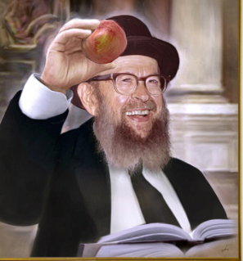

Rav Avigdor Miller, zt”l, constantly taught to be thankful to Hashem for every aspect of life. When it rained, he would encourage people to thank Hashem for the bountiful fruits and vegetables which were, in potential, pouring down from the Heavens. He would explain the beauty in countless creations of Hashem, pointing out how their very shape, color, or size was uniquely suited to the purpose of the Creation.
“If we truly think, Hashem’s wisdom can be seen everywhere. Simply study the apple, the peach, your eye, your hand, and you will surely find a wisdom that can only be Hashem’s. For this we must give thanks; that is what life is all about.” He would point out that rather than create a world of black and white, HaKadosh Baruch Hu filled the world with color and beauty to make it more attractive and pleasurable for people.
A grandchild once watched him sit down to eat an apple. Before making the Brachah (blessing), he examined the apple and exclaimed, “Ribono Shel Olam! Look at this magnificent apple that You created! The wisdom in its waterproof enclosure, the beauty of the deep, tantalizing red color, and the temptingly delicious aroma with which it is perfumed!
“How can I even begin to thank You for the tree it grew on? And to think that You made it all for me!!” With that said, he enunciated the Brachah clearly and distinctly, as if Hashem Himself were sitting there before him!

Reprinted from the Parshas Re’eh 5780 email of Torah U’Tefilah as compiled by Rabbi Yehuda Winzelberg.

The $1800 Donation
By Rabbi Reuven Semah

The following story is told by Rabbi Elimelech Biderman. R’ Feivel was a young man from B’nei Brak in need of funds, who traveled to America to raise money. In one particular city, he decided to hire a driver who would take him around town together with a number of other needy people who were collecting.
To his dismay, there was a very bossy and aggressive individual in the car, who insisted on always being the first to enter at every stop, be it a home or a shul. Although this didn’t seem fair, R’ Feivel decided not to argue and allowed this person to go first.
After the group visited a certain shul, they continued on to their next stop. After the bossy person exited the car, R’ Feivel showed the driver that he had received a check for $1800 at their previous stop. Noticing the name on the check, the driver was surprised, as the person was not known to give such large donations.
The next day the driver met the individual who wrote the check and asked about it.
“The truth is that I had just come to shul after successfully closing a deal that I had been working on,” the person related. “I had made a commitment that if I closed the deal, I would give its ma’aser to the first collector I meet.”
“But there was a different collector who made the rounds in that shul first,” asked the driver.
After thinking for a moment, the businessman responded, “Now that you mention in, I did first use the restroom before entering the shul. That’s where I must have been when the first collector made the rounds.”
First, second, third, or last, a person will receive what is coming to him from the One Above.

Reprinted from the Parashat Hukat Balak 5780 email of Rabbi David Bibi’s Shabbat Shalom from Cyberspace. The story originally appeared in that week’s Jersey Shore Torah Bulletin.

The Legend of the
Special Tzelaf Tree

Once there was a Chasid, a righteous person, who went out for a walk in his vineyard on Shabbos. He only wanted to see how things were doing there, and if anything needed to be done. While he was walking through it, he saw that one of his fences had fallen down, leaving it wide open and unprotected.
The Chasid thought to himself that right after Shabbos he would get to work and fix the fence. However, immediately after having these thoughts, he felt terrible. “How could I have even thought about work on Shabbos Kodesh!”
He decided right then that since he thought about fixing the fence on Shabbos, he would not fix it on Motzaei Shabbos. “In fact,” he said, “I won’t ever fix the fence! I’ll only rely on HaKadosh Baruch Hu to guard and protect the grapes, like I should have relied on Him to begin with!”
When Hashem saw how serious the Chasid was about honoring Shabbos, He made a special fruit tree grow at the exact spot where the hole in the fence was. It closed up the opening and protected the vineyard.
Not only that, but this special fruit tree was called a Tzelaf tree, which is a tree that grows three types of fruit at once. The Chasid was able to live off the fruits of the Tzelaf tree all the remaining days of his life! (Otzar HaMidrashim, Yisro 20:10)

Reprinted from the Parashat Hukat Balak 5780 email of Rabbi David Bibi’s Shabbat Shalom from Cyberspace. The story originally appeared in that week’s Jersey Shore Torah Bulletin.

How to Do Incredible Mitzvahs at Charity Auctions
By Rabbi David Asher

About seven years ago, a man decided that he wanted to be more involved with Chesed and helping people, so he started doing small acts of kindness and called himself “The Mitzvah Man,” so that others would know to call him if they needed help. If someone needed furniture moved, he would call him, and he would happily come. If someone needed a ride somewhere, he would call him, and he would happily come.
After more and more people found out about this Mitzvah Man, he couldn’t keep up with all of the calls he was getting. Other people volunteered to help as well, and before he knew it, it turned into an entire
organization.
Now, seven years later, this organization helps more than twelve thousand people a year. The power of one man’s desire to do good is amazing. Of course, to accomplish anything in this world, we need Hashem’s help. The head of the organization told me that he has seen the Yad Hashem helping him with his Chesed countless times. He began to relate to me just a few episodes.
Six years ago, someone called him and asked for financial help. This person had a large family but couldn’t afford a car, and it was really straining his Shalom Bayit. The head of the organization told him, “I wish I could help you, but this is beyond the scope of what we do. We don’t have that
kind of money available to buy cars.”

“Maybe This is My Opportunity to Help That Family
But he felt terrible turning anybody away. He kept him in mind in case an opportunity would ever arise to help. Shortly after, he was at an auction for charity for the organization Eshel Shabbat, and someone approached him there to buy a car raffle ticket. At first, he wasn’t interested, but then he said, “Maybe this is my opportunity to help that family.” He told his daughter, who was standing right next to him, “I’m buying a ticket for the raffle, and if I win, I’m giving the car to a needy family.” And when the drawing was held that night, the ticket pulled was his. He was so happy to call that family and tell them, “I got you a car.”
Just two years after that, he found out about another family who was struggling who also needed a car. And he told some of the people from the organization, “I think I could help them.” Again, the Eshel Shabbat auction was coming up, and again he purchased a ticket for the car raffle. Amazingly, he won the raffle again for a second time and happily gave the car to that needy family.
Two years ago, someone approached him in dire need of financial help. He told the person, “It’s not really what our organization does. There are other organizations for that. We don’t have that kind of money to give away. We do acts of kindness.” But again, he doesn’t like to tell anybody no.

The Split the Pot Raffle
He said, “Let me see what I can do.” And again he was at an auction, and he saw that the “split the pot raffle” was at $17,000. He said, “I’m going to buy one ticket and put their name on it.” Before the drawing, he went over to the ten year old girl who was going to pick out the winner from a bowl with hundreds of names and asked her, “Please, before you pick the ticket, ask Hashem in public that you
should pick out the name of a needy family.” She did. Almost miraculously, she picked out that one ticket with the name of the family that he bought. Nobody there knew who they were because he put the name of one person from the family on a ticket without their last name.
Everybody can make a big difference in this world. We all have unlimited potential. If we want to do good, we have Hashem there helping us. May we all be Zocheh to use our full potential and at the end of 120 years be called בא בימים“ .”

Reprinted from the Parashat Chaya Sara 5781 email of iTorah.com

How Did He Know?
By Rabbi Sholom DovBer Avtzon

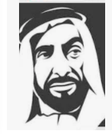

I heard this story when I was a youngster and someone recently reminded me of it. It can be seen in all its details in Taamei Haminhagim pp. 497-499.
Rabbi Moshe Galanti lived in Damascus, which is a Muslim country, and the sheik was a just person, who was loved by the people. In addition to being a fair judge, whenever someone was ill, the family would come to him and ask that he pray on their behalf. Not only did he do so, but he would tell them when to return, and when they came back he informed them if their family member or friend will survive or not.
After some time it became a regular scene. Early in the morning long lines of individuals would line up in front of his palace, to ask him for his prayers and blessings and then that evening or whenever, he instructed them to return, he would tell them what will happen.
People came to Rabbi Galanti, the Rov of that city, and asked him whether they are allowed to ask him as well. Their question was, was the sheik using the power of an avodah zora, or was it a gift from Hashem? When the Rov heard about this phenomenon, he also became curious about this ability of the sheik, and decided to find out.
He called the shamash and told him to ask the sheik if he can visit him. The sheik who was quite learned and had heard that the Jewish rabbi was extremely knowledgeable in many fields, happily agreed to meet him.

The Sheik Asked Rabbi Galenti Certain Questions
When Rabbi Golanti came, the sheik asked him if he was knowledgeable in a certain wisdom. The Rov replied, with the grace of the Creator, I am somewhat knowledgeable in it. The sheik was thrilled and began discussing certain questions he had in it, and was elated with the answers.
Evidently, the rabbi was modest in his declaration that he has some knowledge in it, he is definitely an authority in it.
The time allotted passed by extremely fast and the sheik requested that the rabbi please visit him the following week. Rabbi Golanti agreed, but on the third day, a servant of the sheik was knocking at Rabbi Golanti’s door. The Sheik requests that you visit him today, at your convenience.
Rabbi Golanti replied in the affirmative that he will come, and arrived some hours later.
I apologize for asking you to come today, but my thirst for learning gave me no rest, the sheik said. Can we continue the discussion today? At the end of the discussion, the sheik said, I would greatly appreciate it if we can meet twice a week to discuss these issues.
The Rov replied, he would be happy to do so, however, he cannot promise that he will have the answers. After all, I just study it, in order to understand Jewish law, but I will try my best.

Surprised by the East of How the
Rabbi Answered His Questions
The following week when the Rov came, the sheik had a list of questions and was hoping that at least a few of them would be answered. To his surprise, the rabbi answered all of them without any difficulty.
Rabbi you said you are somewhat knowledgeable in it. I see your humility got the better of you, as you are the leading expert in this field. The Rov simply replied, there is so much more to learn.
The sheik asked him, where did you study all this? And Rabbi Galanti replied, I need to know it to understand the Torah and the greatness of the Creator. So continued their twice a week meetings for some months. Their friendship indeed grew, and his respect for the rabbi was becoming stronger and stronger.
One day during their conversation, the Sheik asked him about the seventh subject, and when the rabbi replied that he has some knowledge in it, the sheik knew that the rabbi knew it very well, and he was thrilled. He fell on his feet and pleaded to Rabbi Galanti to please teach it to him. However, to his dismay, this time Rabbi Galanti turned him down and said, I can’t. It took me years of herculean effort and tremendous expenses to learn it, I can’t just give it away.

The Sheik Offers the Rabbi
Whatever Price He Asks for
I will pay you whatever price you ask, replied the sheik pleadingly. What is my money worth, compared to gaining such wisdom?!
Exactly as you said, replied Rabbi Galanti, so why should I sell it for money? I can only give it away as an exchange, wisdom for wisdom. You teach me something and I will teach you something.
My dear friend there is no wisdom that I have that you are not better qualified than I! If I have something that I can switch with you, I would gladly do so.
Yes, there is something that I would like to know, and that is, how do you know who is going to live and who is going to die?
The sheik paled, that is something I can’t reveal to anyone, I was sworn to secrecy.
I too have that problem, but I figured in order for me to gain wisdom, it is for mine benefit, so it is permissible for me to share it, as I am doing so for my benefit not for yours. The same is by you my dear friend, you are using it for to gain knowledge.
Rabbi, I am willing to do so, however, I can’t divulge it, not because I don’t trust you, but it is because I wish to protect you.
Protect me from what, inquired the Rov.

Whoever is Not Worthy of Knowing
The Secret May Perish on the Spot
Whoever is not worthy to know this secret and founds out, may perish on the spot, replied the Sheik, and I don’t want anything bad to happen to you.
I am not fearful of that happening, replied the Rov.
If so, I will inform you. But you must prepare yourself properly, replied the Sheik. Starting from tonight, you must fast for two days, and in the meal that you eat this evening you should not have any meat or wine. Then if you still want to see, come to me on the third day, after you immerse yourself in water and put on a new set of linen garments.
The Rov agreed and went home and didn’t break his fast even on the morning of the third day. He was somewhat nervous, but felt that he has to found out. Arriving at the palace after he davened shacharis, the guards ushered him and the Sheik greeted him warmly.
He noticed that the rabbi was extremely pale and weak, and said, it is clear that you followed the instructions, so we can proceed.

The Sheik Bolted the Door
The Sheik bolted the door from inside and then opened another door which led into a beautiful garden. He instructed the Rov to follow him and that there would be no talking, besides for the few instructions he gives.
The Rov agreed and after some distance they came to a stream. He then said, Rabbi, we will immerse in the stream and then proceed.
The Rabbi was becoming more and more bewildered, but he did as was instructed.
After walking another few hundred feet the Sheik began to tremble. He whispered to the Rov, Rabbi if you want to turn back, this is your last chance. The Rov assured him that he is alright.
They then came to a small hut made out of marble and precious stones, with pure silver carved doors that put the doors of the sheiks palace to shame. Rabbi Galanti never saw a house so beautiful. The Sheik whispered, before you enter you must bow down, and before the rov could reply, the sheik bowed for a while. Seeing him bowed, the Rov was relieved.
When the Sheik arose, he respectfully knocked on the door and then with his head bowed he humbly entered the room, and bowed down seven times. Knowing that it is expected of him to do so also, Rabbi Galanti decided to say the possuk, shivisi Hashem l’negdi sumid – I place Hashem constantly in front of me, and bowed to the side.

The Most Exquisite Curtain the Rov Had Ever Seen
Opposite the door was the most exquisite curtain the Rov had seen, and the Sheik instructed the Rov to move the curtain and look at what is behind the curtain. There he saw four familiar words laid out in a most beautiful way, the words he had just uttered, shivisi Hashem l’negdi sumid, and under it he saw the four letters of Hashem’s name, Yud, Hei, Vov and Hei. He sighed a sigh of relief thankful that he did not bow to an avodah zora.
They then returned in silence to his room, and Rabbi Galanti said, I saw some words and letters, but that doesn’t explain how you know who will live and who night!
The letters you saw, are the letters that spell the name of the true Creator. He created this world, and is continuously in charge of it. When I hold up a name, either the name begins to shine, which means that that person is going to recover. If there is a shade over the letters that means they will pass on.
When Reb Moshe came home he broke out in an inconsolable cry. He sat there with tears rolling down his cheeks. After a few moments he said, we say this possuk every day, and mention Hashem’s name numerous times a day. So why don’t we have this present and ability, while the Sheik does?!
Because look at the respect and awe he [the Shiek] has of Hashem’s name, even though he has no idea about Him and His Torah and mitzvos, and therefore he was granted this special ability. But we who do know Hashem, how much more respect should we demonstrate, when we daven?!!
A Jewish Girl Stuck in
Hostile East Jerusalem

Rabbi Yoel Gold told a story about a young girl who was rewarded for her great hessed and kiddush Hashem. The girl, “Chana,” was living in Israel at the time. She wasn’t feeling well, her head was spinning, but her friend had asked her for a favor.
When she was on the way to go do the favor, she was dizzy and confused and got on the next bus that pulled up, and she promptly fell asleep. She didn’t realize she had gotten on a blue and white Palestinian bus. Chana woke up 25 minutes later in the middle of Eastern Jerusalem in an Arab settlement. She got off the bus, and there wasn’t another bus stop going back in the direction she came.
A young girl alone in a Palestinian settlement at night is an extremely dangerous situation. Chana was so afraid; she took out her phone and saw it died. She looked around; she saw houses in bad shape with boarded windows and Arabic signs everywhere. Immediately, she said a perek of tehillim. Chana saw one house that wasn’t in bad shape, it had a grass lawn and unsealed windows.

A Young Palestinian Woman Answered the Door
She came up with a plan to act like a liberal American student coming to interview Palestinians, braced herself to knock, and prayed to Hashem it would work. A young Palestinian woman answered the door in full garb. Immediately, her eyes lit up and she said, “Chana?” Chana’s plan went out the window! Who was this girl? The Palestinian girl said in Hebrew, “Chana! Hi! I still have your card!” She went to a bookshelf and pulled out a card that Chana recognized right away.
Six months earlier, Chana was doing some volunteer work with Aish, and the program was being hosted in the King Solomon Hotel. During the program, Chana took it upon herself to get to know every staff member in the hotel, from housekeeping, to waiter staff, to bellmen. On the last day of the program, she noticed there was a staff member she hadn’t seen before, a young Palestinian girl, about 18, serving coffee.
Chana introduced herself and asked this girl all about her life, to which the girl told her she was working here with other members of her family and putting herself through medical school. When the hessed program ended, Chana made sure to hand out thank you cards to every staff member working in the hotel, and it resonated with this Palestinian girl enough to keep Chana’s card.

Welcome into the House with Open Arms
Chana was so relieved! She was welcomed into the house with open arms, and the family recognized her, because they worked at the hotel too! The girl’s uncle offered to drive Chana where she needed to go. When they got to the security checkpoint, an Israeli soldier looked inside the car and saw a religious girl with an Arab man and young woman and asked, “Hakol beseder—Is everything ok?” Chana reassured him, “These are my friends!” and they all laughed.
Hashem sees everything we do and pays us back for our good deeds, at the right time. Chana did volunteer work, she tried to do a favor for her friend when she was sick, and most importantly, she made staff members feel validated and seen. She took the time to respect people and make them feel special, and she did an incredible kiddush Hashem, which ultimately saved her life.
Giving to others is such a precious way to serve Hashem, and it is a beautiful lesson to ingrain in our children from a young age.

Reprinted from the Parashat Vayera 5781 email of Jack E. Rahmey based on the teachings of Rabbi Amram Sananes.
Rav Huna’s Sour
Barrels of Wine

When 400 barrels of wine belonging to Rav Huna turned sour, he was very distressed. The Sages attempted to console him. “Examine your deeds,” the Sages advised. Rav Huna was taken aback, “Do you suspect me of sinning?”
“We certainly can’t suspect Hashem of an unjust act,” they replied. “We know that you don’t give half of your produce to your farmer, but you don’t pay him correct dues.”
“This is because he is a thief and a cheat. He takes more than his half, so I am not required to give him his full due.”
“Aha! But our Sages say that one who steals from a thief is also called a thief, and you have no right to withhold payment!”
Rav Huna conceded that they were correct and thanked Hashem that He gave him a punishment in this world, so he could know what to do in the future and be cleansed for the World to Come.

Reprinted from the Parshas Vayeira 5781 email of Torah Sweets Weekly.
The Greedy Liar and
The Grateful Merchant
By Elchonon Isaacs

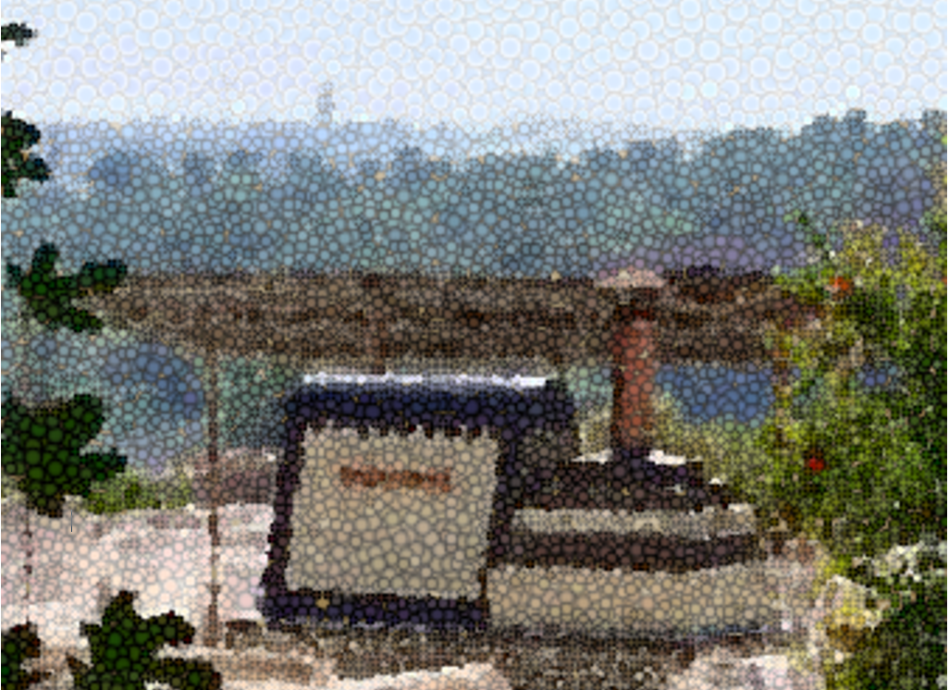
A stylized rendering of the resting place of Rabbi Yehuda Ben Attar in Fez, Morroco.

It was not uncommon for Rabbi Yehuda Ben-Attar (1655-1733), chief rabbi of Fez, Morocco, to receive visitors of all sorts, seeking his wise counsel. Many local Muslims would consult with the rabbi on personal matters and ask him to arbitrate their business dealings. But when a Muslim businessman showed up having traveled all the way from distant Tunis, it was an anomaly indeed.
The visitor was extremely wealthy and had many holdings in his hometown, including a partnership with a Jewish fabric dealer. The wealthy Muslim would provide the money for the fabric dealer to buy various textiles. He would then sell them, and share the profits with his benefactor. Their partnership remained harmonious for many years, and both men prospered.
Over time, complete trust developed between the two, and the magnate would deposit large sums of money with the fabric merchant with no written contracts or records of any sort.

The Fabric Dealer was Blinded by Temptation
One day, the businessman deposited a substantial sum, and the fabric dealer, who had never handled such vast amounts, was blinded by temptation. He calculated that it would take 10 years of ordinary business for him to earn such a sum of money.
Several weeks passed, and the wealthy man came to pick up his share of the profits. The fabric dealer welcomed him graciously. As soon as the guest was seated and served a glass of tea, the host spoke. “I am surprised, my dear partner. It is already a few weeks that I have not been working on your behalf, as I am waiting for a deposit. Where have you been?”
At first, the businessman did not understand. Then he thought his partner was joking with him. But it soon dawned on him that he had fallen into a trap.
His mind raced as he contemplated his next move. He sorely regretted having trusted the merchant so much that he hadn’t even recorded the transaction; now he would be unable to take legal action.
Suddenly, an idea popped into his head. Like many citizens in Morocco, he had heard about the great and pious Rabbi Yehuda Ben-Attar. “You know what,” he said to the fabric merchant, “swear to me in the name of Rabbi Yehuda Ben-Attar that you did not receive any money from me in the past few weeks, and that you do not have any money of mine.”

Forced into Taking an Oath
At first, the fabric merchant was shocked. He tried to excuse himself with all sorts of ruses, but the wealthy businessman continued pressing him to swear. Realizing that his continued refusal was tantamount to admitting guilt, he paled and shook with fright as he took the oath, especially when he mentioned the name of Rabbi Yehuda. The wealthy man was highly disappointed and left the home of his erstwhile partner, knowing that he had no further recourse.
Time passed and the thief’s pangs of guilt were replaced with feelings of joy.
Now, he was richer than he had ever hoped to become, and he threw a party for all his friends. As the wine flowed like water, he recounted how he had struck rich in a “good deal” and that his strong business acumen and good fortune guaranteed that he would have enough for the rest of his life.
As the evening wore on, he went to the cellar to fetch some fine wine. The cellar also served as his warehouse, in which he stored his fabrics. There were also barrels of oil, lumber, and adhesive materials there. Standing in the cellar and inspecting his great wealth gave him untold joy.

The Forgotten Candle
When he returned to the party with his wine, he forgot the candle he had brought with him. Soon the strong smell of smoke filled the house. Before he had a chance to look for the source, pillars of fire were coming from the cellar. The candle had fallen on a bolt of fabric, and in a short time, there was no trace of any merchandise.
“I came to honor the holy rabbi, to tell this story and express my gratitude,” continued the rich businessman who had traveled all the way to Fez to see Rabbi Yehuda Ben-Attar. “I am certain the ruin of my ex-partner is because he used your name to swear falsely.”
The visitor took out a purse full of money and tried to give it to the rabbi as a token of his gratitude and admiration. But Rabbi Yehuda, who worked as a silversmith and never took any public funds for himself, declined the gift. “Firstly, I don’t take gifts from people. Second, I cannot benefit from money coming as a token of thanks for the downfall of another, however deserving he may be of Divine punishment.”
Rabbi Yehuda directed him to the charity director in Fez, and the money was distributed among the poor.

Reprinted from the Parashat Toldos 5781 email of Chabad.Org Magazine.

When I was a youngster and first heard this story, my melamed said it was mathematics and Rabbi Galanti explained that it is needed to understand the measurement of a k’zayis and rivi’is etc. The next subject was astronomy and he explained it is needed for kiddish hachodesh etc. I didn’t include these details in the text as it is not noted in Taamei haminhagim.
My melamed also added, and if it remains as is, that means the person will be ill for a lengthy time until they pass on. He also added the following, when we asked him, how did the sheik learn this? He replied the sheik said: Many years ago, my grandfather wanted to find the true G-d and serve Him. He invited the priests of many religions and spoke to them, he traveled to many countries to observe them, but alas he came to the conclusion, that they are all false. When he returned home, he constantly prayed in his room, asking G-d to help him serve Him. He cried, I spent years on searching for You, and couldn’t find You. One night he had a dream and an angel appeared to him and said, G-d has heard your prayer. I am going to reveal Him to You. He then showed him G-d’s name. My grandfather passed the secret on to my father and my father gave it to me. I didn’t include these details in the text as they also are not mentioned in the original story. Reprinted from the Parshas Lech Lecha 5781 email of Rabbi Avtzon’s Weekly Story email. He is a veteran mechanech (educator) and the author of numerous books on the Chabad Rebbeim and their chassidm. Rabbi Avtzon can be contacted at avtzonbooks@gmail.com

